**BX3081: INTERACTIVE MARKETING**

ASSESSMENT TASK 1 COLLEGE OF BUSINESS, LAW AND GOVERNANCE



**INDIVIDUAL TASK COVER SHEET**

|  |  |  |  |  |  |  |  |  |  |
| --- | --- | --- | --- | --- | --- | --- | --- | --- | --- |
| *Student*  *Please sign, date and attach cover sheet to front of assessment task for all hard copy submissions* | | | | | | | | | |
| **SUBJECT CODE** | BX3081 | | | | | | | | |
| **STUDENT FAMILY NAME** | **Student Given Name** | **JCU Student Number** | | | | | | | |
| Tran | Le Binh | 1 | 3 | 4 | 7 | 6 | 1 | 1 | 2 |
| **ASSESSMENT TITLE** | Literature Review | | | | | | | | |
| **DUE DATE** | 05/ 08/ 2018 | | | | | | | | |
| **LECTURER NAME** | Pamela Wildheart Pilapil | | | | | | | | |
| **TUTOR NAME** | Pamela Wildheart Pilapil | | | | | | | | |
| **Student Declaration**   1. This assignment is my original work and no part has been copied/ reproduced from any other person’s work or from any other source, except where acknowledgement has been made (see *Learning, Teaching and Assessment Policy 5.1*). 2. This work has not been submitted for any other course/subject (see *Learning, Teaching and Assessment Policy 5.9*). 3. This assignment has not been written for me. 4. I hold a copy of this assignment and can produce a copy if requested. 5. This work may be used for the purposes of moderation and identifying plagiarism. 6. I give permission for a copy of this marked assignment to be retained by the College for benchmarking and course review and accreditation purposes.   [Learning, Teaching and Assessment Policy](http://www.jcu.edu.au/policy/allitoz/JCU_076643.html) 5.1. A student who submits work containing plagiarised material for assessment will be subject to the provisions of the [Student Academic Misconduct Requirements.](http://www.jcu.edu.au/policy/allitoz/JCUDEV_005375.html)  **Note definition of plagiarism and self plagiarism in Learning, Teaching and Assessment Policy:**  **Plagiarism:** reproduction without acknowledgement of another person’s words, work or expressed thoughts from any source. The definition of words, works and thoughts includes such representations as diagrams, drawings, sketches, pictures, objects, text, lecture hand-outs, artistic works and other such expressions of ideas, but hereafter the term ‘work’ is used to embrace all of these. Plagiarism comprises not only direct copying of aspects of another person’s work but also the reproduction, even if slightly rewritten or adapted, of someone else’s ideas. In both cases, someone else’s work is presented as the student’s own. Under the Australian *Copyright Act 1968* a copyright owner can take legal action in the courts against a party who has infringed their copyright.  **Self Plagiarism:** the use of one’s own previously assessed material being resubmitted without acknowledgement or citing of the original.  **Student Signature**  Tran Le Binh **Submission date 05/ 08/ 2018** | | | | | | | | | |

# Introduction

The application of academic theory is knowns as one of the effective measurement in advertising the new products. The analysis about Technology Acceptance Model, Social power theory, Para-social interaction theory will be provided below to help the marketers achieve the deep insight about the tendency of promoting the new products.

# Body

## **Technology Acceptance Model (TAM)**

The Technology Acceptance Model (TAM) refers to how users adopt and utilize the technology (Who, 2011). TAM also indicates that the elements of user friendly and perceived usefulness impact on the level of acceptance new technology. TAM is illustrated in figure 1.

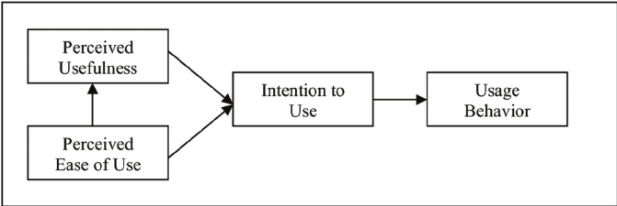

Figure 1: Technological Acceptance Model (Who, 2011)

The degree of accepting technology varies according to young people and the elderly. For the young people, about 95% of teenagers possessed a smartphone in 2018, which rose by 73% in 2015 (Anderson and Jiang, 2018). For the old people, in 2014, the America’s elderly was considered as the late majority adopters for the technology. In the field of lagging in mobile phone, there were about 77 seniors, which compared to 91 adults. In the field of lagging in internet, there were about 59 seniors, which compared to 86 adults. In the field of lagging in broad band, there were about 47 seniors, which compared to 70 adults (Smith, 2014). The statistics for the seniors was provided in figure 2.

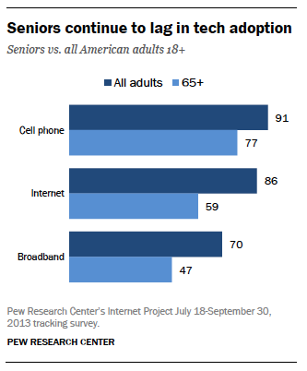

Figure 2: Seniors continue to lag in tech adoption (Smith, 2014)

The reason why the seniors hardly adopt the technology because they lacked of confidence to learn and use properly technology gadgets. Moreover, the seniors also required the assistance in using electronic devices. There was about 73% seniors requiring help when utilizing new technology devices (Anderson and Perrin, 2015). The statistics was provided in figure 3.

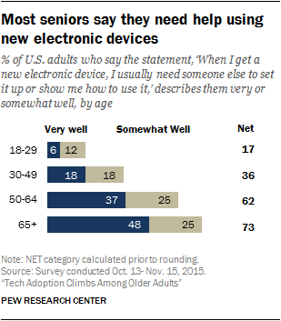

Figure 3: Most senior required the assistance when using technology device

(Anderson and Perrin, 2015).

Gradually, in 2017, there was a significant change in the level of adopting technology for the elderly. About 42% of the seniors possessed their own electronic devices and 33% of the adults who are above 65 years olds used technology to go online (Anderson and Perrin, 2017).

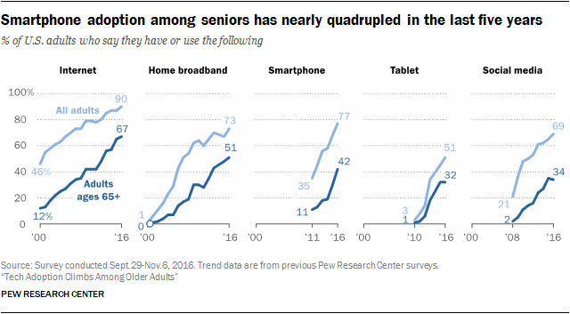

Figure 4: Smartphone owned by the seniors

Apart from the mobile devices, there are some products that has been manufactured and used widely to improve the life and solve the physical barriers for the elderly. Especially, the advertisements for those products are also provided in the social media platforms. For example, the Ecobee3 Thermostat sensor is used to turn on the heating and cooling system based on the stored data, automatically deliver the comfort temperature when the home is occupied. The Nest Protect controls the abnormal conditions of household appliances when people are away from home and identifies the people who is walking in the dark. Amazon Echo/Alexa allows the seniors browse the website, shop online, obtain weather reports through voice activation (The Senior List, 2017).

## **Social network analysis**

Social power theory is known as the ability of exert influence from one person or a group to the another party in order to do his or her will. There are five types of social power in terms of reward power, coercive power, legitimate power, referent power, expert power (French and Raven, n.d). In the aspect of marketing, the reward power, expert power, coercive power is commonly used in the aspect of marketing.

To be more specific, reward power is the influence ability by providing a reward (Social Power, n.d.). In 2017, people queued at Robinsons Heeren from 11am for the day before Black Friday deals in order to purchase the products with a sharp discount (Sue-Ann, 2017). However, the Black Friday generates the negative impact of human beings’ health such as lose sleep, raise blood pressure and cause physical injuries from the crowd (Cromar, 2015). Therefore, in my opinion, the application of reward power become the double-edged sword in the marketing strategy

Expert power refers to the influence ability by an expert who possesses knowledge and expertise in some fields (Merchant, 2018). In order to advertise the sports products and sportswear, some brands such as Adidas and Nike have been conducting the contracts with David Beckham, Kevin Durant, Maria Sharapova, Lebron James, Derrick Rose to become their brand endorsement (Ang, 2017).

Coercive power is the influence ability related to the punishment threat like monetary fines or personal disapproval (Social Power, n.d). In August 2017, Singapore government impose the law on the point-of-sale display (POSD) of tobacco products including cigarettes, cigars, beedies, ang hoon and other tobacco products and the fine of up to $10,000, imprisonment of up to 6 months (Ministry of Health, 2017). One week after that law was imposed, some convenience stores in Clementi suffered a 10 to 20 per cent drop in cigarette sales (The Straight Time, 2017).

## **Para-social interaction**

Para-social interaction theory illustrates the one-side interaction between the media performers who are celebrities, actors and the audience (Ballantine and Martin, 2005). Through this interaction, it forms the intimacy relationship at a distance between the media consumers and the media character. In marketing aspect, choosing appropriate endorsement is commonly used to develop para-social interaction. In the past, the consumers hardly interact with the celebrities and they assessed the products credibility through the celebrities or representatives with their values and fame and the fans lacked of interaction with the representatives. Moreover, the users were easy to boycott the products when the image of celebrities is destroyed.

For example, Tiger Woods is one of the most persuasive example about how the endorsement could effected the company brand significantly. Before 2008, he was the famous and professional golfer in the world. He earned about $200 million when becoming the endorsement for Nike (Chung et al, 2013). However, after 2008, Tiger Woods was criticized about his sex scandal. Nike continued to keep Tiger Woods as the representatives. Consequently, the consumers began to boycott the Nike’ products. In fact, Nike suffered a loss of $1.7 million in sales and 105,000 customers (Sokolovska, 2016).

Now, the users could interact directly with the celebrities when using social media like Facebook, Instagram, Twitter. For example, when Cristiano Ronaldo post the Nike, Herbalife, Tag Heuer and Abbott Labs’ products on social media, his total interactions and video views reached 2.4 million and achieved 927 million interactions like likes, comments, shares and video views. Cristiano Ronaldo received $35 million from the sponsors in 2016 (Badenhausen, 2017).

## **Analysis**

The above analysis about three theories proves that the Technology Acceptance Model, Social power theory, Para-social interaction theory has the correlation relationship. The more people use mobile devices frequently, the more information about promoting new products and the more exchanging communication between the user and the brand endorsement the users have. Hence, the consumers can easily track the origin of the products and raise the brand equity in terms of brand loyal, brand awareness, brand images and perceived value in the consumers’ perspectives.

# Conclusion

The Technology Acceptance Model, Social power theory, Para-social interaction theory is considered as the three efficient tools to advertise the products in the marketing industry. The Technology Acceptance Model helps the marketers acknowledge the trends of using electronic devices for both the young people and the elderly. Therefore, the new technological products will be generated appropriately according to the types of age group. The Social power theory classifies different methods of advertising products that attracts the consumers purchase the products. Para-social interaction theory plays a vital role in creating the intimacy relationship between the brand endorsement and the consumers and strengthening the products credibility.

**References**

Al Bawaba. (2002). *David Beckham Endorses Castrol Lubricant Brand*. Retrieved from <https://www.albawaba.com/business/david-beckham-endorses-castrol-lubricant-brand>

Anderson, M., & Perrin, A. (2015). *Barriers to Adoption and Attitudes Towards Technology.* Retrieved from <http://www.pewinternet.org/2017/05/17/barriers-to-adoption-and-attitudes-towards-technology/>

Anderson, M., & Perrin, A. (2017). *Tech Adoption Climbs Among Older Adults*. Retrieved from <http://www.pewinternet.org/2017/05/17/tech-adoption-climbs-among-older-adults/>

Anderson, M., & Jiang, J. (2018). *Teens, Social Media & Technology 2018*. Retrieved from <http://www.pewinternet.org/2018/05/31/teens-social-media-technology-2018/>

Ang, K. (2017). *5 Athletes with Bigger Endorsement Deals Than Odell Beckham Jr.'S Nike Gig*. Retrieved from <https://moneyish.com/ish/5-athletes-with-bigger-endorsement-deals-than-odell-beckham-jr-s-nike-gig/>

Badenhausen, K. (2017)*. Cristiano Ronaldo Produced Nearly $1 Billion in Value for Sponsors On Social Media*. Retrieved from <https://www.forbes.com/sites/kurtbadenhausen/2017/06/15/cristiano-ronaldo-produces-nearly-1-billion-in-value-for-sponsors-on-social-media-this-year/#1fc1db9b57df>

Ballantine, P. W., & Martin, B. A. (2005*). Forming Parasocial Relationships in Online*

*Communities*. Advances in Consumer Research, 32, eds, 197-201.

Chung, K. Y., Derdenger, T. P., & Srinivasan, K. (2013). *Economic Value of Celebrity Endorsements: Tiger Woods Impact on Sales of Nike Golf Balls*. Marketing Science,32(2), 271-293.

Cromar, D. (2015). *Five Ways Black Friday Shopping Affects Your Health*. Retrieved from <http://www.aedstoday.com/Five-Ways-Black-Friday-Shopping-Affects-Your-Health_b_150.html#.W2HAve94k2w>

French, J. R., & Raven, B. (n.d.). *The Bases of Social Power*. Power and Influence in Groups. Retrieved from <http://www.communicationcache.com/uploads/1/0/8/8/10887248/the_bases_of_social_power_-_chapter_20_-_1959.pdf>

McGee, R., & Warms, R. (2013). *Theory in Social and Cultural Anthropology: An Encyclopedia, Network Theory/Social Network Analysis*. 595-597.

Merchant, P. (2018). 5 Sources of Power in Organizations. Retrieved from <https://smallbusiness.chron.com/5-sources-power-organizations-14467.html>

Ministry of Health. (2017). Retrieved from <https://www.moh.gov.sg/content/moh_web/home/pressRoom/pressRoomItemRelease/2017/point-of-sale-display-of-tobacco-products-to-be-banned-from-1-au.html>

Russell, C. A., Stern, B. B., & Stern, B. B. (2006). *CONSUMERS, CHARACTERS, AND PRODUCTS: A Balance Model of Sitcom Product Placement Effects*. Journal of Advertising*,35*(1), 7-21.

Smith, A. (2014). *Older Adults and Technology Use*. Retrieved from <http://www.pewinternet.org/2014/04/03/older-adults-and-technology-use/>

Social Power. (n.d.). Retrieved from <https://psychology.iresearchnet.com/social-psychology/social-influence/social-power/>

Sokolovska, A. (2016). *Impact of Celebrity Endorsement on Consumer Buying Behavior*. Retrieved from <https://www.guided-selling.org/impact-of-celebrity-endorsement-on-consumer-buying-behavior/>

Sue-Ann, C. (2017). *Shoppers Throng Stores for Black Friday Deals; Queue at Robinsons Starts at 11am The Day Before.* Retrieved from <https://www.straitstimes.com/singapore/shoppers-throng-stores-for-black-friday-deals-queue-starts-at-robinsons-11am-the-day>

The Senior List. (2017). *Smart Home Technology for Senior Living: 5 Great Products*. Retrieved from <https://www.theseniorlist.com/2017/01/smart-home-technology-products/>

The Straight Time. (2017). *Cigarette Sales Down as Shops Comply with Product Display Ban*. Retrieved from <https://www.todayonline.com/singapore/cigarette-sales-down-shops-comply-product-display-ban>

Who, X. (2011). *Extending TAM: Success Factors of Mobile Marketing*. American Academic & Scholarly Research Journal,1,1.